Media Release and Waiver

I ___________________________________________________________________ ,
(Name)

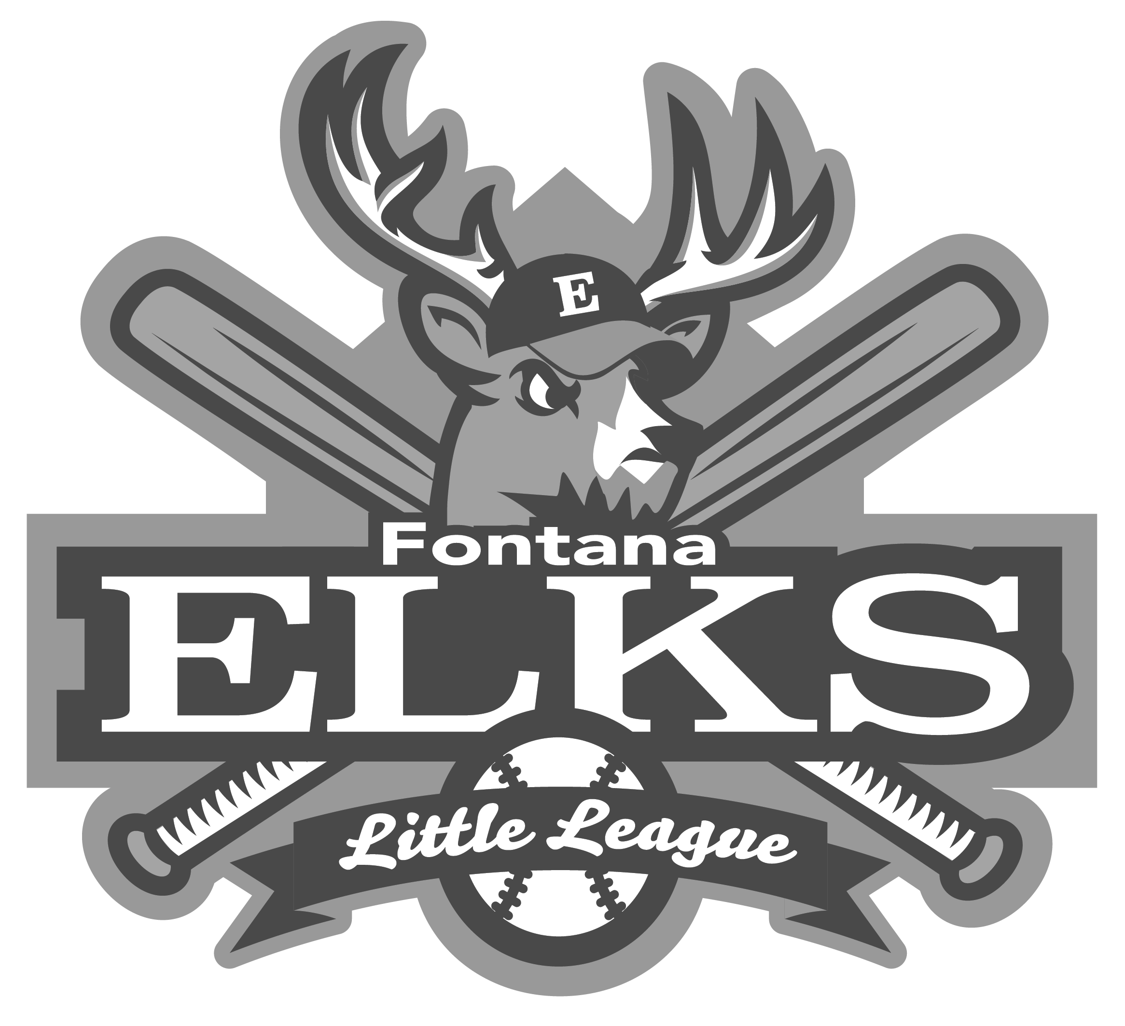
of ___________________________________________________________________ ,
(Address)
hereby give permission to Fontana Elks Lodge Little League, to use photographs, voice recordings, or video taken of me during the games and events associated with Local League in any manner to help promote the league activities as determined in the sole discretion of the Local League. Such use could include publications, media releases, announcements, electronic or otherwise, and on league websites or social media pages. I understand that neither I nor my child/ward will receive any compensation if such image appears in any of the manners listed above or any other manner that the league deems appropriate. I agree that such image is the property of Local League.
___________________________________________________ _______________
(Signature) (Date)
(If the above is a minor, the section below must be completed by a parent or guardian)
I ___________________________________________________________________ ,
(Name)

of ___________________________________________________________________ ,
(Address)

the parent guardian of the above listed minor, hereby give my permission to
(check one)
Fontana Elks Lodge Little League to use photographs, voice recordings, or video taken of the above listed minor during the games and events associated with Local League in any manner to help promote the league activities as determined in the sole discretion of the Local League. Such use could include publications, media releases, public announcements, electronic or otherwise, and on league websites or social media pages. I agree that neither I, nor the above listed minor, will receive any compensation if such image appears in any of the manners listed above or other manner that the league deems appropriate. I agree that such image is the property of Local League.
___________________________________________________ _______________
(Signature) (Date)

